**Bivariate Analysis**

The goal of bivariate analysis is to explore how each independent variable relates to the target variable — HeartDisease.

This helps identify which features show strong patterns, correlations, or differences between patients with and without heart disease.

1.**Chest Pain Type vs Heart Disease**

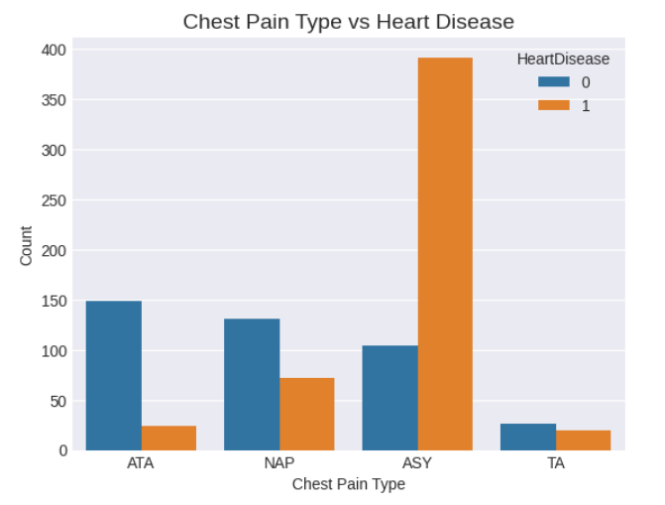

The Chest Pain Type variable shows a clear relationship with heart disease.

Patients experiencing asymptomatic **chest pain (ASY) have the highest incidence of heart disease**, while those with typical angina (TA) or non-anginal pain (NAP) tend to be healthier.

This aligns with medical understanding — asymptomatic patients may already have underlying cardiac issues that go unnoticed.

2.**ST Slope vs Heart Disease**

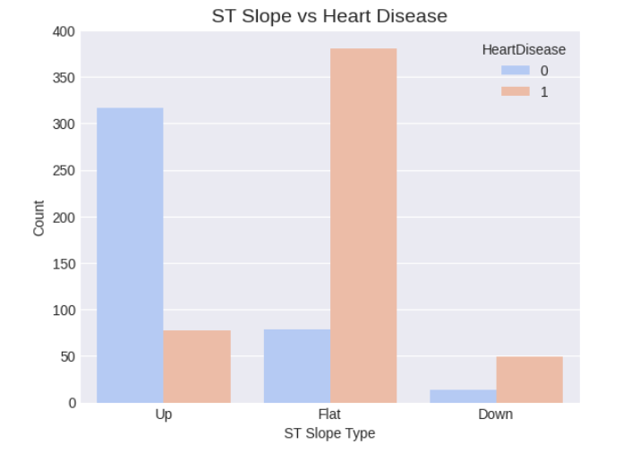

The ST_Slope feature shows that patients with a **flat or down-sloping ST segment** are far more likely to have heart disease.

Although “Flat” slope appears most frequently, the **proportion of heart disease cases within it is very high**.

“Down” slope, though rarer, is even more strongly associated with heart disease.

Conversely, an **“Up” slope** is typically seen in healthy individuals.

3.**Exercise Angina vs Heart Disease**

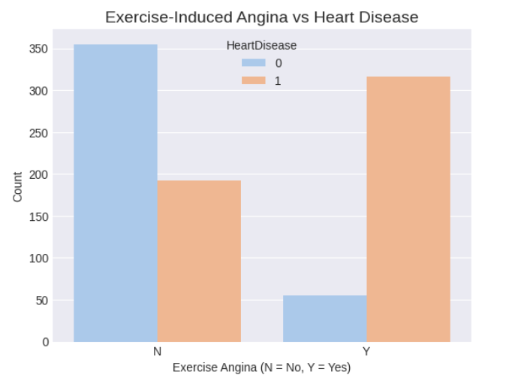

The presence of **Exercise Angina (Exercise-induced chest pain)** is a **strong positive indicator** of heart disease.

Most patients with **‘Y’ (Yes)** for ExerciseAngina have heart disease, while those with **‘N’ (No)** are more likely to be healthy.

This reinforces the clinical understanding that chest discomfort during exertion is a key symptom of cardiovascular problems.

4. **Maximum Heart Rate vs Heart Disease**

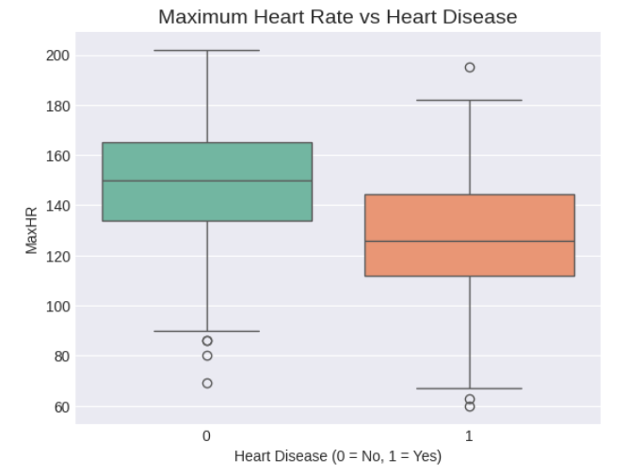

The MaxHR distribution reveals that individuals with lower maximum heart rates are more prone to heart disease.

Healthy individuals reach higher maximum heart rates during exercise, while those with cardiac issues often have restricted or abnormal heart rate responses.

This variable thus captures an important functional difference between the two classes.

5. **Oldpeak vs Heart Disease**

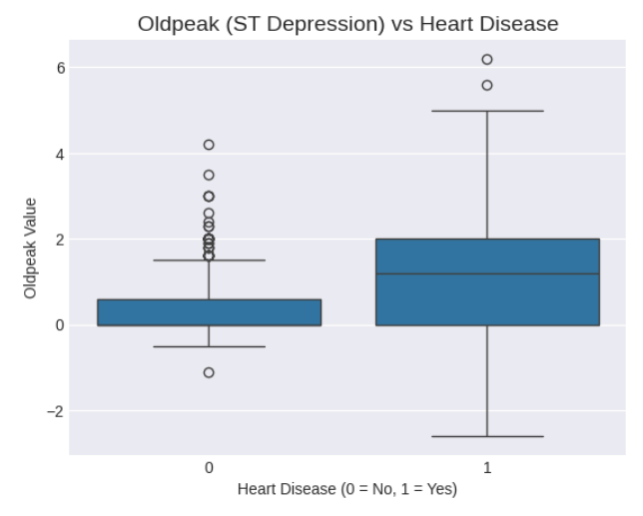

**Oldpeak** measures the ST depression induced by exercise relative to rest.  
 The plot shows that higher *Oldpeak* values are strongly associated with heart disease.  
 In medical terms, a larger ST depression suggests greater levels of myocardial ischemia.  
 Therefore, this variable provides a **quantitative measure** of the heart’s abnormal response to stress.

6. **Age vs Heart Disease**

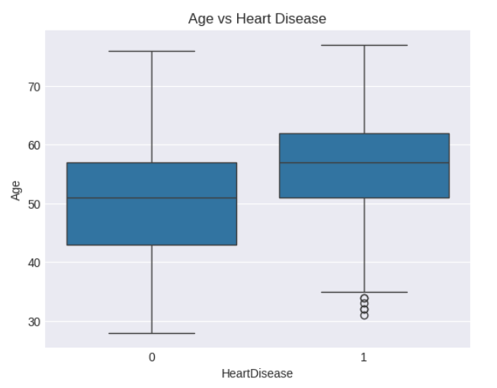

The **Age** distribution indicates that heart disease becomes more prevalent among older patients.

While younger individuals are less likely to show disease symptoms, the risk increases steadily after age 45–50.

This trend is consistent with real-world cardiovascular risk factors